Snub Cube

Definition
# Source: AI Source: Provided by: [Data Path: Persons Table -> ID Column: 1, Name_En Column: Motasem Essam] -> From: [ChatGPT] on [7/25/2026]
The Snub Cube, also known as the Snub Cuboctahedron or Cubus Simus, is a convex Archimedean solid composed of 32 equilateral triangular faces and 6 square faces.
It has 60 edges and 24 vertices. It is characterized by its twisted arrangement of square faces and its chiral structure, meaning it exists in two distinct mirror-image forms: left-handed and right-handed.
Its dual polyhedron is the Pentagonal Icositetrahedron, a Catalan solid.

Geometric Structure
# Source: AI Source: Provided by: [Data Path: Persons Table -> ID Column: 1, Name_En Column: Motasem Essam] -> From: [ChatGPT] on [7/25/2026]
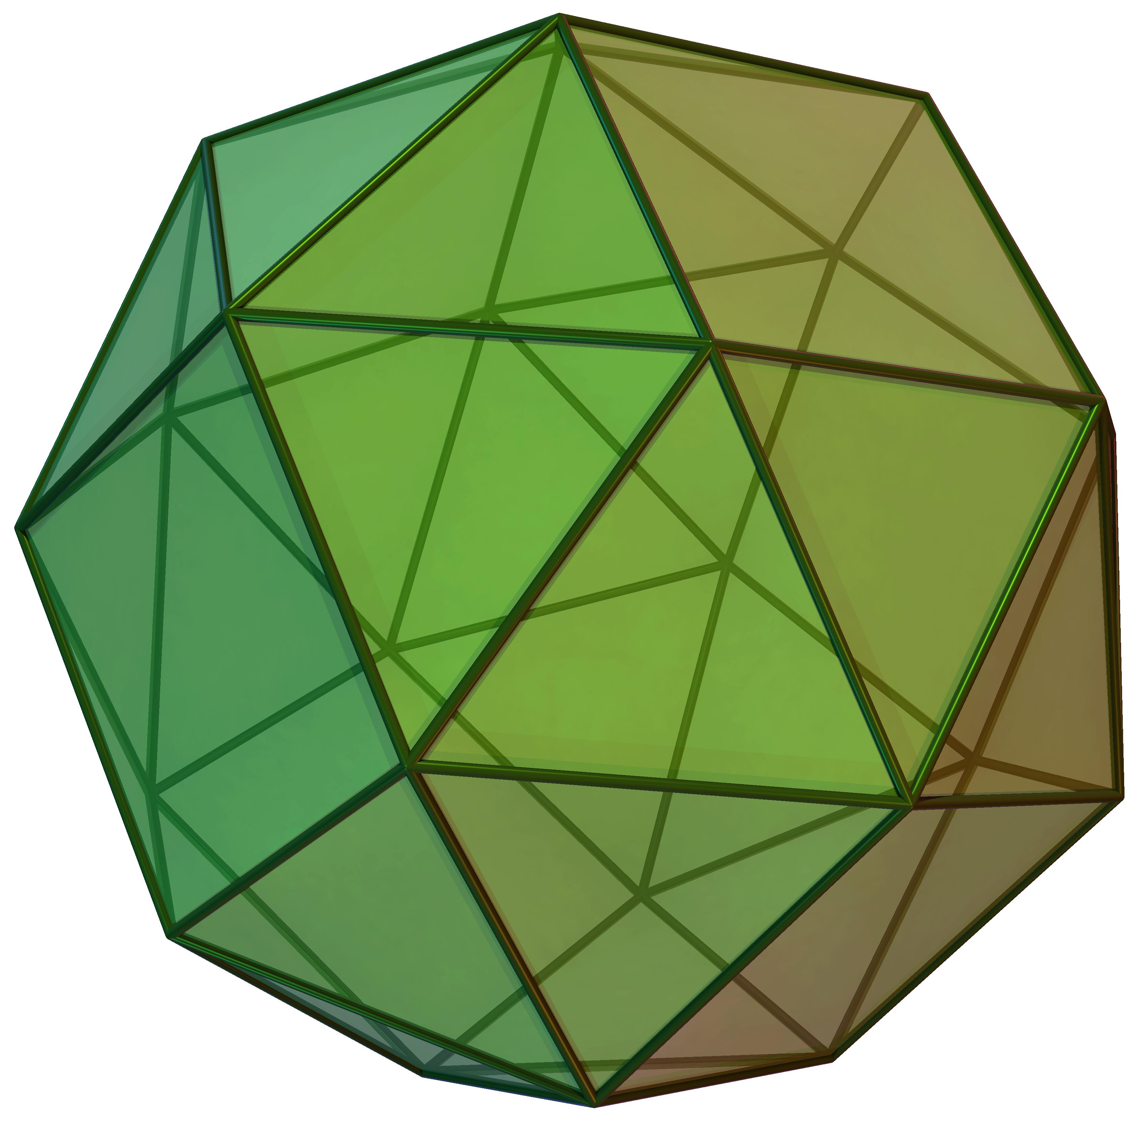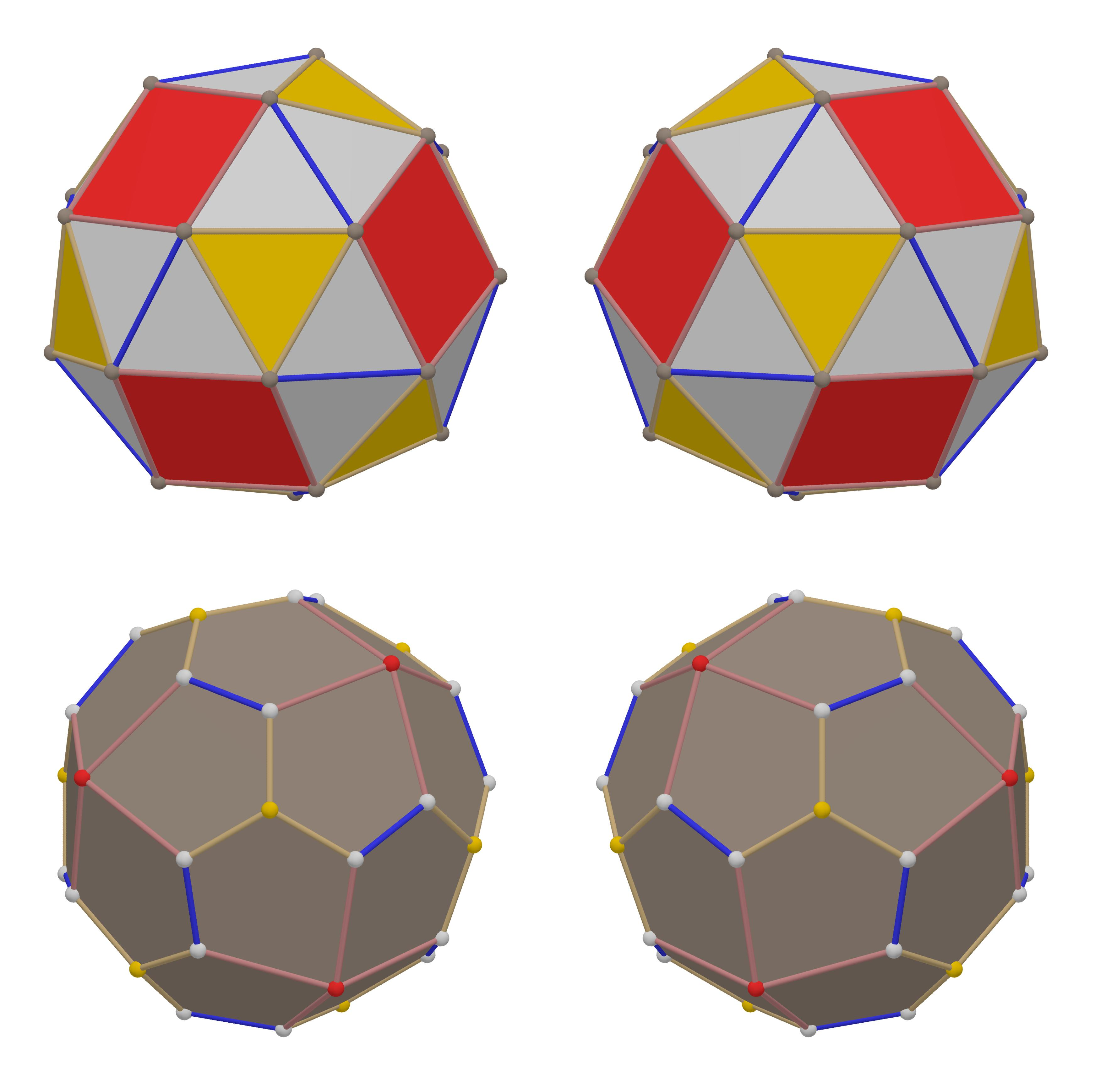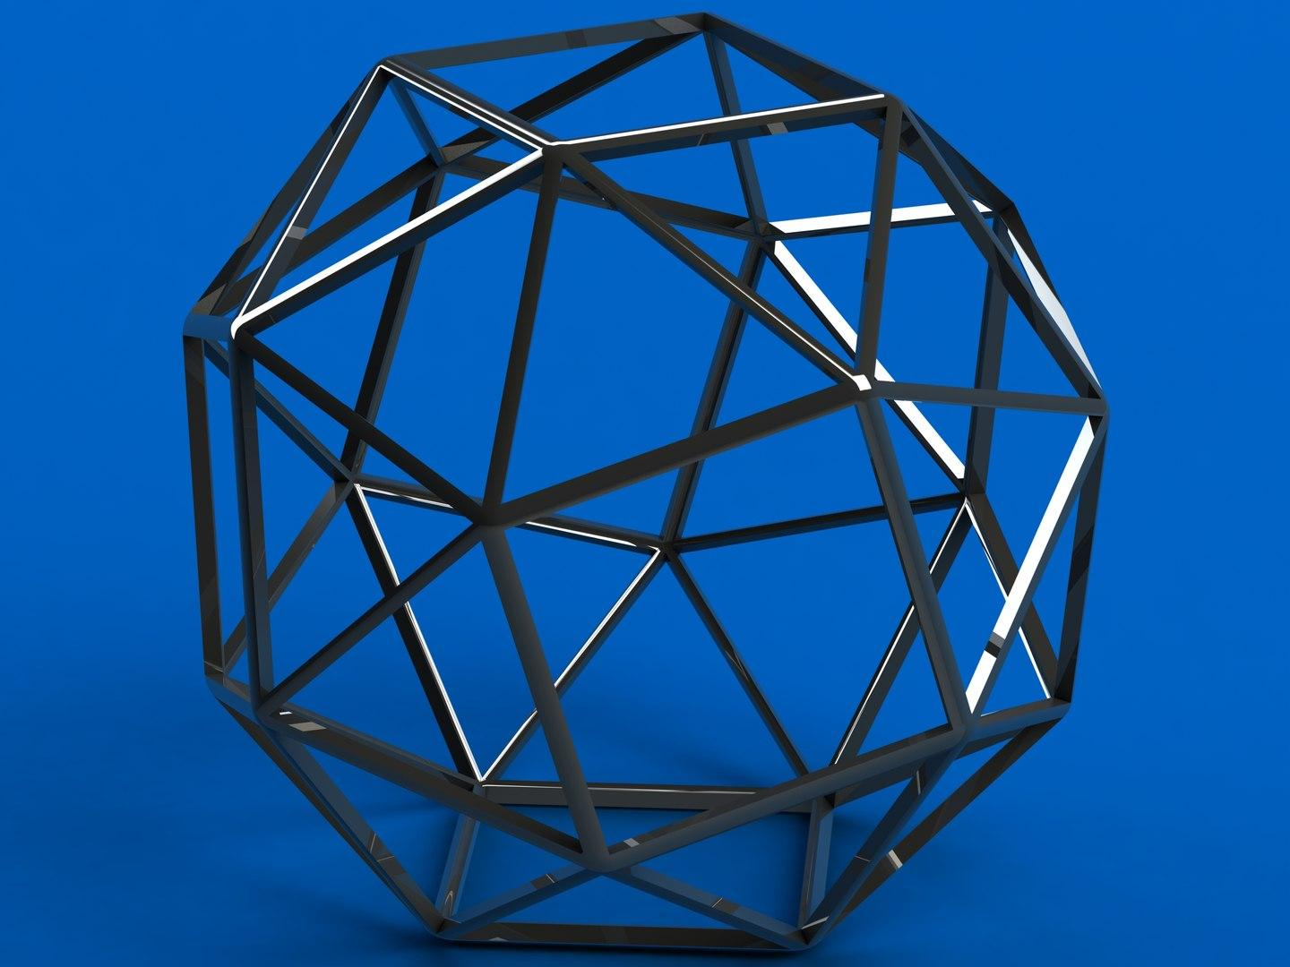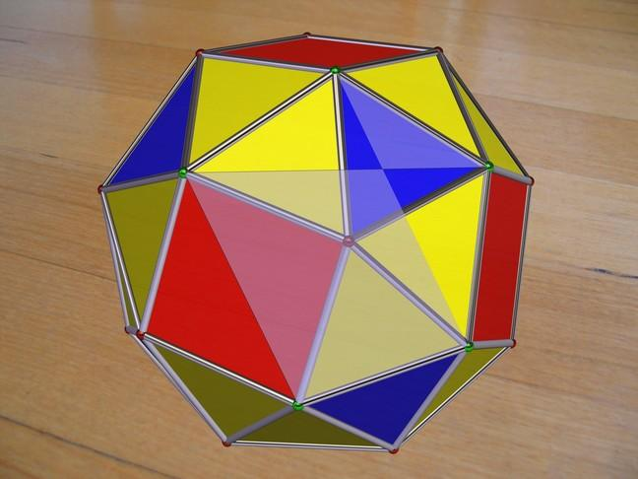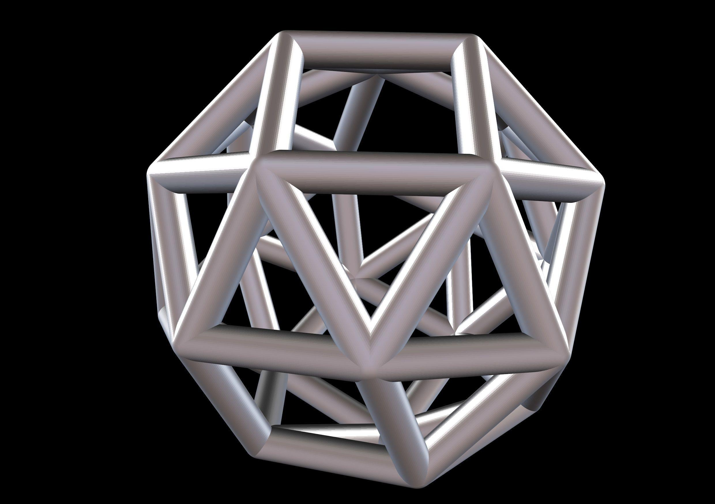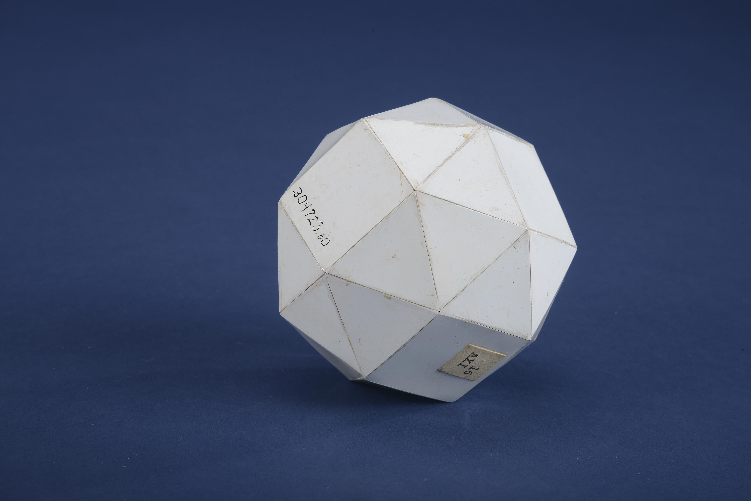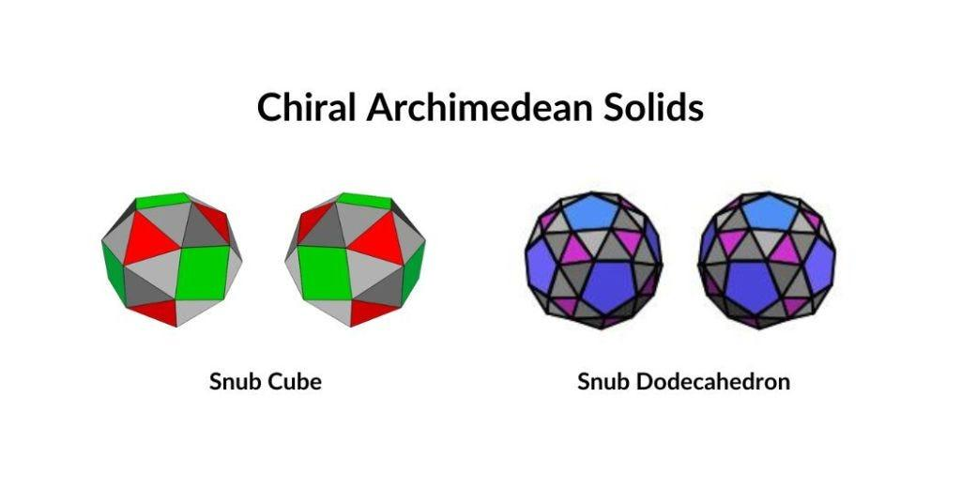
The Snub Cube has a distinctive arrangement of polygonal faces:
- 32 Equilateral Triangles: Form the majority of its surface.
- 6 Squares: Correspond to the six original faces of a cube and are twisted in the same rotational direction.
- Twisted Arrangement: The triangular faces connect the rotated squares to form a continuous convex surface.
- Two Enantiomorphs: The left-handed and right-handed forms are mirror images that cannot be superimposed by rotation alone.

Face Composition
# Source: AI Source: Provided by: [Data Path: Persons Table -> ID Column: 1, Name_En Column: Motasem Essam] -> From: [ChatGPT] on [7/25/2026]
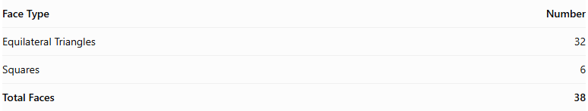
Face Type | Number
Equilateral Triangles | 32
Squares | 6
Total Faces | 38

Mathematical Properties
# Source: AI Source: Provided by: [Data Path: Persons Table -> ID Column: 1, Name_En Column: Motasem Essam] -> From: [ChatGPT] on [7/25/2026]
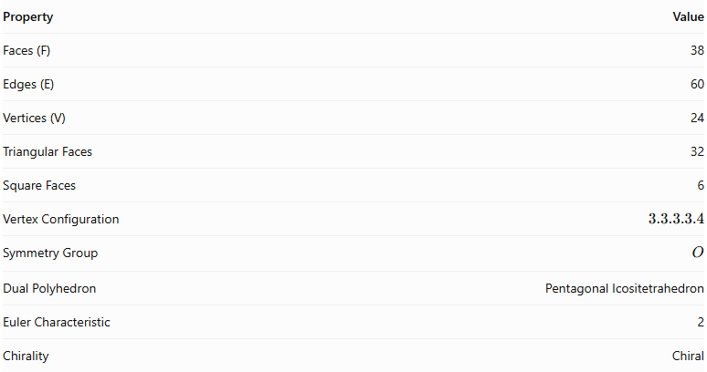
Property | Value
Faces (F) | 38
Edges (E) | 60
Vertices (V) | 24
Triangular Faces | 32
Square Faces | 6
Vertex Configuration | $$3.3.3.3.4$$
Symmetry Group | $$O$$
Dual Polyhedron | Pentagonal Icositetrahedron
Euler Characteristic | 2
Chirality | Chiral
Euler characteristic:
$$V-E+F=24-60+38=2$$
Surface area (where $a$ is the edge length):
$$A=(6+8\sqrt{3})a^{2}$$

Geometric Characteristics
# Source: AI Source: Provided by: [Data Path: Persons Table -> ID Column: 1, Name_En Column: Motasem Essam] -> From: [ChatGPT] on [7/25/2026]
- Convex Structure: All faces form a convex, closed polyhedral surface.
- Uniform Faces: All 38 faces are regular polygons, and every edge has the same length.
- Vertex Arrangement: Four equilateral triangles and one square meet at every vertex.
- Chirality: The solid has two mirror-image forms, known as left-handed and right-handed Snub Cubes.
- Rotational Symmetry: It has rotational octahedral symmetry, represented by the group $O$.
- Twisted Squares: Its six square faces are rotated consistently in one direction, producing the characteristic snub arrangement.

Geometric Construction
# Source: AI Source: Provided by: [Data Path: Persons Table -> ID Column: 1, Name_En Column: Motasem Essam] -> From: [ChatGPT] on [7/25/2026]
The Snub Cube can be constructed through the snub operation applied to a cube-related polyhedral arrangement.
- Begin with a cube.
- Separate and rotate its six square-face regions in the same rotational direction.
- Arrange the squares so that the gaps between them can be filled with equilateral triangles.
- Add the 32 triangular faces to complete the convex polyhedron.
Reversing the direction of rotation produces the opposite enantiomorph.

Related Geometric Solids
# Source: AI Source: Provided by: [Data Path: Persons Table -> ID Column: 1, Name_En Column: Motasem Essam] -> From: [ChatGPT] on [7/25/2026]
- Cube – The underlying geometric reference for the snub construction.
- Cuboctahedron – A related Archimedean solid.
- Rhombicuboctahedron – Another related cube-based Archimedean solid.
- Snub Dodecahedron – Another chiral Archimedean solid.
- Pentagonal Icositetrahedron – The dual polyhedron.

Main Classification
# Source: AI Source: Provided by: [Data Path: Persons Table -> ID Column: 1, Name_En Column: Motasem Essam] -> From: [ChatGPT] on [7/25/2026]
Solid Geometry
└── Types of Solids
└── Snub Cube
├── Equilateral Triangular Faces
├── Square Faces
├── Vertices
├── Edges
├── Types of Snub Cube
│ ├── Left-Handed Snub Cube
│ └── Right-Handed Snub Cube
├── Chiral Symmetry
└── Geometric Properties

Key Points
# Source: AI Source: Provided by: [Data Path: Persons Table -> ID Column: 1, Name_En Column: Motasem Essam] -> From: [ChatGPT] on [7/25/2026]
- The Snub Cube is a convex Archimedean solid.
- It has 32 equilateral triangles and 6 squares.
- It contains 38 faces, 60 edges, and 24 vertices.
- Four triangles and one square meet at every vertex.
- It exists in two mirror-image forms: left-handed and right-handed.
- Its dual is the Pentagonal Icositetrahedron.

Conclusion
# Source: AI Source: Provided by: [Data Path: Persons Table -> ID Column: 1, Name_En Column: Motasem Essam] -> From: [ChatGPT] on [7/25/2026]
The Snub Cube is a distinctive Archimedean solid characterized by its twisted square arrangement, numerous triangular faces, and chirality. Its two mirror-image forms and its dual relationship with the Pentagonal Icositetrahedron make it an important example of symmetry and duality in solid geometry.

